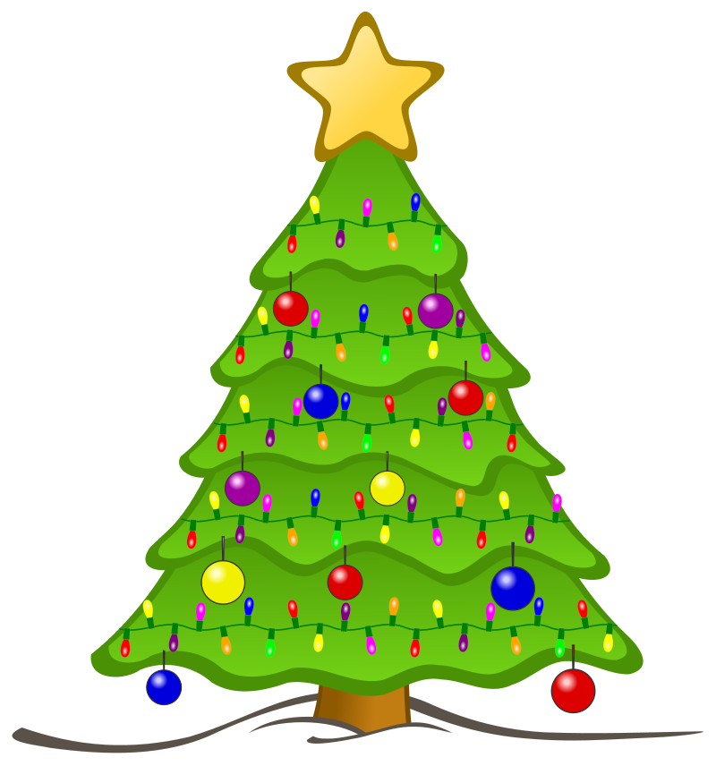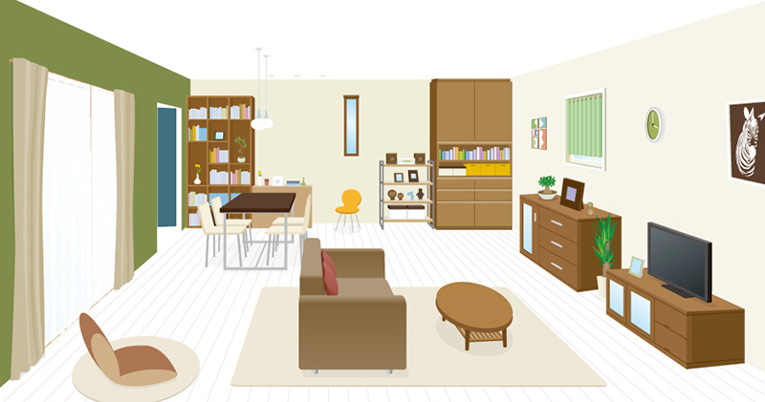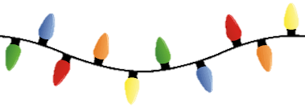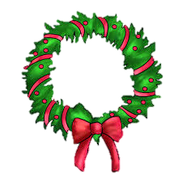

toys ________________________________________________________ candy _____________________________________________________

reindeer___________________________________________________ elf _________________________________________________________

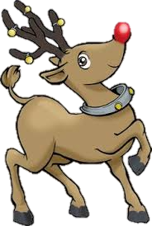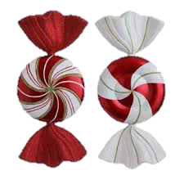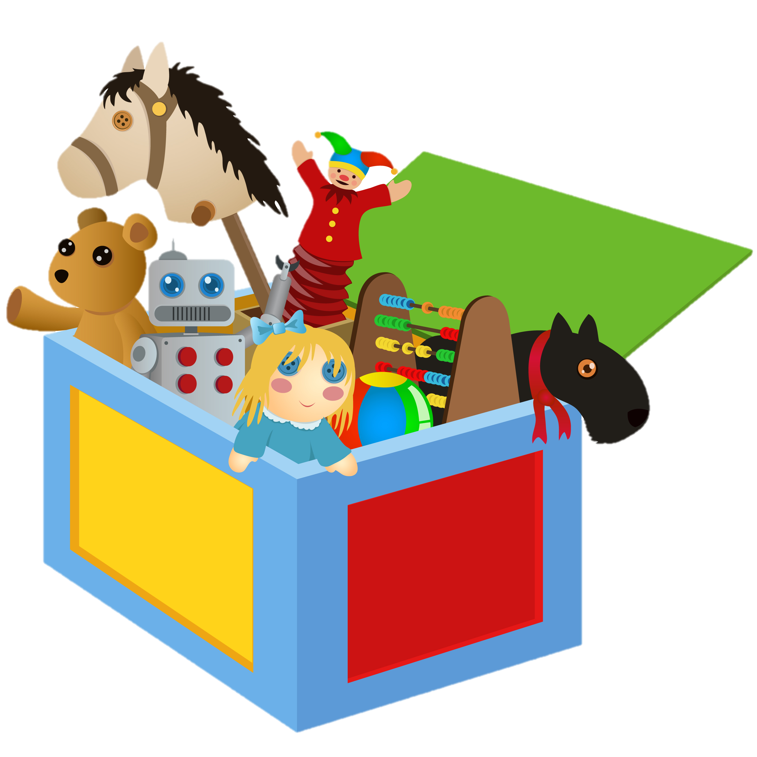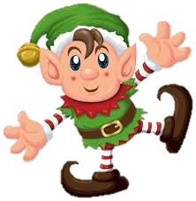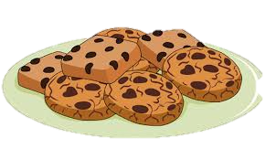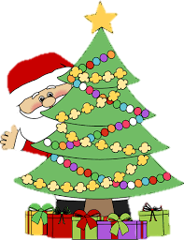

Name: __________________________ Name: __________________________



reindeer

candy

Santa

elf

**Make and answer the questions for the picture above.**

1. Q: _______________________________________________________________________

A: _______________________________________________________________________

2. Q: _______________________________________________________________________

A: _______________________________________________________________________

3. Q: _______________________________________________________________________

A: _______________________________________________________________________

4. Q: _______________________________________________________________________

A: _______________________________________________________________________

**Make and answer the questions for the picture above.**

1. Q: _______________________________________________________________________

A: _______________________________________________________________________

2. Q: _______________________________________________________________________

A: _______________________________________________________________________

3. Q: _______________________________________________________________________

A: _______________________________________________________________________

4. Q: _______________________________________________________________________

A: _______________________________________________________________________

