Name: _______________________________
1. Write as many sentences as you can for the picture below.

________________________________________________________________________________________________________________________________________________________________________________________________________________________________________________________________________________________________________________________________________________________________________________________________________________________________________________________
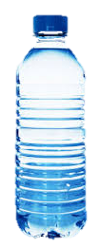
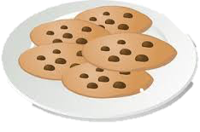
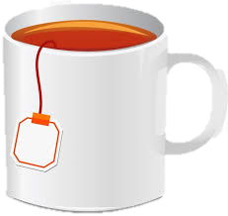
2. Write 5 questions for the items below.

1. Q: _______________________________________________________________________________________________________________
A: _______________________________________________________________________________________________________________
2. Q: _______________________________________________________________________________________________________________
A: _______________________________________________________________________________________________________________
3. Q: _______________________________________________________________________________________________________________
A: _______________________________________________________________________________________________________________
4. Q: _______________________________________________________________________________________________________________
A: _______________________________________________________________________________________________________________
5. Q: _______________________________________________________________________________________________________________
A: _______________________________________________________________________________________________________________
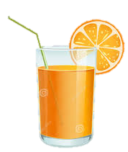
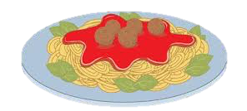
3. Use the picture below to answer your partner’s questions.

Name: _______________________________
1. Write as many sentences as you can for the picture below.

________________________________________________________________________________________________________________________________________________________________________________________________________________________________________________________________________________________________________________________________________________________________________________________________________________________________________________________
2. Write 5 questions for the items below.

1. Q: _______________________________________________________________________________________________________________
A: _______________________________________________________________________________________________________________
2. Q: _______________________________________________________________________________________________________________
A: _______________________________________________________________________________________________________________
3. Q: _______________________________________________________________________________________________________________
A: _______________________________________________________________________________________________________________
4. Q: _______________________________________________________________________________________________________________
A: _______________________________________________________________________________________________________________
5. Q: _______________________________________________________________________________________________________________
A: _______________________________________________________________________________________________________________
3. Use the picture below to answer your partner’s questions.

Name: _______________________________
Write as many sentences as you can for the picture below.

________________________________________________________________________________________________________________________________________________________________________________________________________________________________________________________________________________________________________________________________________________________________________________________________________________________________________________________
Write 5 questions for the items below.

1. Q: _______________________________________________________________________________________________________________
A: _______________________________________________________________________________________________________________
2. Q: _______________________________________________________________________________________________________________
A: _______________________________________________________________________________________________________________
3. Q: ______________________________________________________________________________________________________________
A: _______________________________________________________________________________________________________________
4. Q: _______________________________________________________________________________________________________________
A: _______________________________________________________________________________________________________________
5. Q: _______________________________________________________________________________________________________________
A: _______________________________________________________________________________________________________________
Use the picture below to answer your partner’s questions.

